




STATEMENT OF COMMON GROUND BETWEEN HUNTINGDONSHIRE DISTRICT COUNCIL, CAMBRIDGESHIRE AND PETERBOROUGH COMBINED AUTHORITY AND CAMBRIDGESHIRE COUNTY COUNCIL

October 2026

Contents
Statement of Common Ground between Huntingdonshire District Council, CAMBRIDGESHIRE AND PETERBOROUGH COMBINED AUTHORITY AND CAMBRIDGESHIRE COUNTY COUNCIL 1
1. Introduction 1
2. Parties Involved 3
3. Signatories 3
4. Administrative areas covered/ Strategic geography 4
5. DEVELOPMENT OF THE A141 AND ST IVES TRANSPORT IMPROVEMENTS SCHEME AND ITS ASPIRATIONS 9
6. Strategic Matters to be addressed 11
7. Strategic Matter 1: DELIVERY TIMETABLE OF THE a141 TRANSPORT IMPROVEMENT SCHEME TO SUPPORT GROWTH IDENTIFIED IN HUNTINGDONSHIRE’S LOCAL PLAN TO 2046 12
8. Strategic matter 2: FUNDING OF THE A141 AND ST IVES TRANSPORT IMPROVEMENTS SCHEME AND THE APPROACH TO INFRASTRUCTURE REQUIREMENTS AND DEVELOPER CONTRIBUTIONS 14
9. FUTURE ACTIONS 16
10. Governance arrangements 17
11. Next Steps 17
Appendix 1- RECORD OF MEETINGS AND CORRESPONDENCE WITH CAMBRIDGESHIRE AND PETERBOROUGH COMBINED AUTHORITY AND CAMBRIDGESHIRE COUNTY COUNCIL REGARDING THE A141 AND ST IVES TRANSPORT IMPROVEMENTS SCHEME 19
Appendix 2- relevant evidence documents 21
Appendix 3- work undertaken up to the end of September 2025 on the A141 and St Ives TRANSPORT Improvements Scheme. 22
Appendix 4- Trip generation estimates based on no further growth above that of the huntingdonshire local plan. 23

Statement of Common Ground between Huntingdonshire District Council, CAMBRIDGESHIRE AND PETERBOROUGH COMBINED AUTHORITY AND CAMBRIDGESHIRE COUNTY COUNCIL

- Introduction
This document presents a Statement of Common Ground (SoCG) between Huntingdonshire District Council (HDC), Cambridgeshire and Peterborough Combined Authority (CPCA) and Cambridgeshire County Council (CCC) (as the Highways Authority) in relation to the developing Huntingdonshire Local Plan to 2046 (HLP) with regard to the proposed A141 and St Ives Transport Improvements Scheme.
It has been prepared jointly by HDC, CPCA and CCC in accordance with the National Planning Policy Framework (NPPF) and Planning Practice Guidance (PPG) to collaborate on identification of strategic matters, document cross-boundary matters and progress in cooperation to address these matters.
The statutory provisions relating to the duty to cooperate were introduced by the Localism Act 2011 and are set out in section 33A of the Planning and Compulsory Purchase Act 2004. It places a legal duty on local planning authorities such as HDC to engage constructively, actively and on an ongoing basis with prescribed bodies as identified in Part 2 of the Town and Country Planning (Local Planning) (England) Regulations 2012 on strategic cross boundary matters to maximise the effectiveness of the local plan preparation.
HDC is the Local Planning Authority for the Huntingdonshire administrative area. CPCA is the prescribed body as defined in Part 2 of the Town and Country Planning (Local Planning) (England) Regulations 2012 (as amended) as the integrated and strategic transport authority and mayoral authority for Cambridgeshire and Peterborough. CCC is the prescribed body representing the local Highways Authority.
HDC, CPCA and CCC are obliged under the Duty to Cooperate to engage and work together on relevant strategic matters in a proportionate and meaningful manner.
HDC has engaged with CPCA on the development of the HLP including on matters relating to the CPCA’s Local Growth Plan, HDC’s Infrastructure Delivery Study and the A141 and St Ives Transport Improvements Scheme. The CPCA has been formally consulted on Local Plan consultations in accordance with the Town and Country Planning (Local Planning) (England) Regulations 2012, where they responded to the Preferred Options Draft Local Plan to 2046 consultation in 2025. High level strategic engagement has also been ongoing on topics including but not limited to growth in the North Huntingdon Opportunity Zone, promotion of a defence investment cluster, economic planning, housing, investment and place-making (more detail can be found in Appendix 1).
HDC has engaged with CCC on the development of the HLP including on matters relating to HDC’s Infrastructure Delivery Study, the A141 and St Ives Transport Improvements Scheme, Land Availability Assessments, proposed allocations. CCC has been formally consulted on Local Plan consultations in accordance with the Town and Country Planning (Local Planning) (England) Regulations 2012, where they responded to the multiple consultations across 2023, 2024 and 2025 (more detail can be found in Appendix 1). HDC are currently collaborating with CCC on Huntingdonshire’s Strategic Transport Study.
HDC has engaged with National Highways on aspects relating to the strategic road network, including the implications of the proposed development sites on the A1 and the A14 at the Brampton Hut junction.
This SoCG set outs the basis on which the parties have actively and constructively worked together to meet the requirements of the Duty to Cooperate. The statement sets out the areas of agreement and outstanding matters between parties relating to the delivery of the A141 and St Ives Transport Improvements Scheme and other transport and travel matters as far as they relate to the delivery of the proposed strategic sites located in the North Huntingdon Opportunity Zone at Lodge Farm, Wyton Airfield, and Land North of A141 between the Racecourse and A1307, and Giffords Park, including the matters of delivery prospects and funding.
- Parties Involved
The parties involved in this Statement of Common Ground are:
- Huntingdonshire District Council
- Cambridgeshire and Peterborough Combined Authority
- Cambridgeshire County Council

- Signatories
The signatories on behalf of Huntingdonshire District Council are:

Clara Kerr - Head of Planning Infrastructure and Public Protection
Clara Kerr |  | 4/9/2026
Name |  | Date

The signatories on behalf of Cambridgeshire and Peterborough Combined Authority are:

Tim Bellamy, Assistant Director Transport
Tim Bellamy |  | 4/9/2026
Name |  | Date

Matthew Lutz, Transport Programme Manager
Matthew Lutz |  | 4/9/2026
Name |  | Date

The signatories on behalf of Cambridgeshire County Council are:
Jamie Cooke, Service Director: Transport and Connectivity
Jamie Cooke |  | 29/10/2026
Name |  | Date

Jeremy Smith, Head of Sustainable Transport and Strategy
Jeremy Smith |  | 29/10/2026
Name |  | Date

- Administrative areas covered/ Strategic geography

This SoCG sets out the areas of agreement and outstanding matters between parties relating to the delivery of the A141 and St Ives Transport Improvements Scheme and other transport and travel matters as far as they relate to the, delivery of the proposed strategic sites located in the North Huntingdon Opportunity Zone at Lodge Farm, Wyton Airfield, and Land North of A141 between the Racecourse and A1307, and at Giffords Park to the east of St Ives, including the matters of delivery prospects and funding.
The CPCA covers the county of Cambridgeshire and the Peterborough City Council local authority areas. HDC’s local authority area falls within the Combined Authority’s administrative area.
HDC also sits within the administrative area of CCC which acts the highways authority for the County.
The CPCA, in its role as the integrated and strategic transport authority, commissioned CCC to develop the A141 and St Ives Transport Improvements Scheme.
The CPCA has also prepared the Local Growth Plan which was approved in October 2025. The Local Growth Plan sets out the Combined Authority’s plan for growth to 2050. As part of the aim to focus on growing priority sectors within the Mayoral Authority area a place-based approach is set out identifying four ‘Opportunity Zones’. The Local Growth Plan, page 124 states that:
“…Opportunity Zones are designed to crowd in investment to areas, allowing the embedding or Growth of priority sectors. This will drive forward both the foundational economy and the priority sector economy of each area – while also driving the whole CPCA economy”
One such Opportunity Zone is the North Hunts Growth Cluster located around the north of Huntingdon. The Cluster is composed of six key projects, with the primary aim of supporting the Cluster’s growing and evolving economy. It holistically addresses development, with investments in housing, commercial enterprises and connectivity combined to deliver on the wider area’s potential. One of the lynchpins to the opportunity zone is the delivery of improvements to the A141 through a new bypass and enhancements to transport and travel infrastructure around northern Huntingdon, and between there and within St Ives.
HDC included the ambitions of the North Hunts Growth Cluster within the Preferred Options Draft Local Plan to 2046 illustrating the part that it will play in supporting the ambitions of the CPCA. Part of this is through the proposed allocation of strategic sites at: North Huntingdon 2: Land North of A141 between the Racecourse and A1307, North Huntingdon 3: Lodge Farm, North of A14, North Huntingdon, 4: Wyton Airfield. It will also contribute to enhancing accessibility of the proposed allocation Huntingdon 1: Hinchingbrooke Hospital which is scheduled for redevelopment.
Another proposed allocation to the east of St Ives known as Gifford Park comprising 1,750 new homes, 4.6ha of employment land, a mobility hub and ancillary uses is related more specifically to the St Ives improvements elements of the scheme.
These integrated priorities lead to the functional geographical area of Huntingdonshire District being the most appropriate in relation to the strategic matters of delivery of the A141 and St Ives Transport Improvements Scheme for this SoCG (see Figure 1). The A141 also provides a strategic link between Fenland District Council’s area and the A1/ A14 so upgrades around Huntingdon will benefit a wider area.
Figures 2 and 3 identify at a lower geography the strategic site allocations included within the Preferred Options draft Local Plan to 2046, overlaid with the North Hunts Growth Corridor (Figure 2) and the Indicative A141 and St Ives Travel Network Improvements – Updated Package as at October 2025 (Figure 3).

Figure 1: Area Covered by Statement of Common Ground
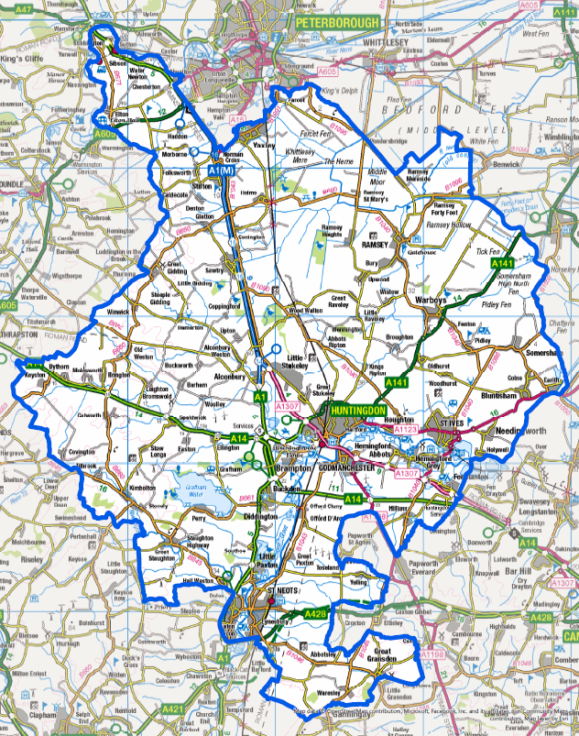

Figure 2: Local Plan Strategic site allocations and North Huntingdon Growth Corridor
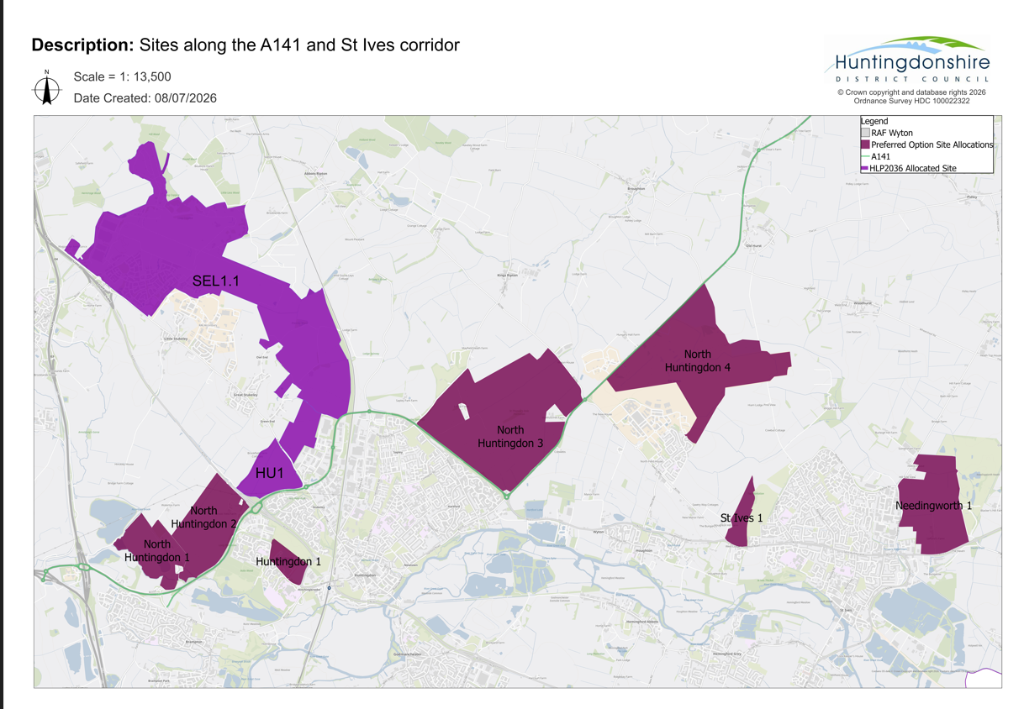

Figure 3: Indicative A141 and St Ives Travel Network Improvements – updated package as at October 2025
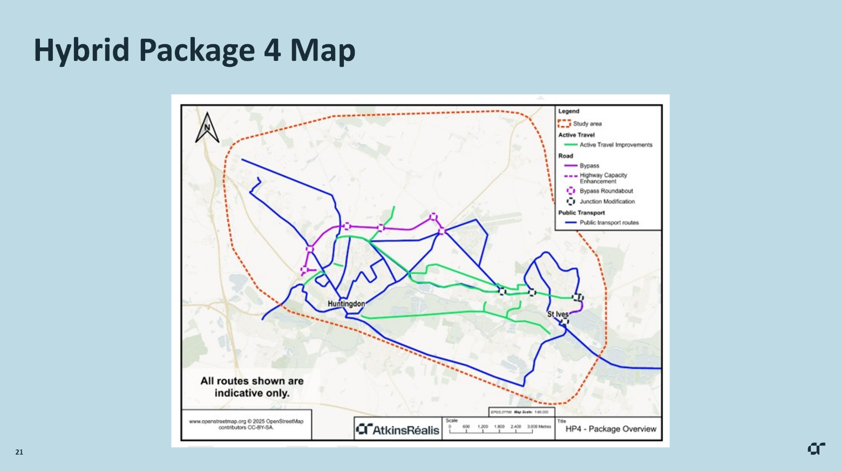

- DEVELOPMENT OF THE A141 AND ST IVES TRANSPORT IMPROVEMENTS SCHEME AND ITS ASPIRATIONS

The need for the scheme
CPCA, CCC and HDC all acknowledge that there is a need for the A141 and St Ives Transport Improvements Scheme. This has been recognised since the Third Cambridgeshire Local Transport Plan 2011-2031: Long Term Transport Strategy published in 2015 which identified the need for A141 capacity enhancements around Huntingdon including safeguarding of a future A141 bypass alignment and capacity upgrades between Huntingdon and Wyton Airfield.
Despite improvements arising to traffic conditions from the A14 upgrades with the main route opened in May 2020 the A141 is still operating significantly over capacity and the local area suffers from:
- traffic jams and unreliable journey times
- road safety issues
- poor noise and air quality conditions
- rat-running on minor roads and nearby villages
- not enough safe, off-road cycle and walking options
- not enough good public transport.
The A141 facilitates connections to and from:
- the A14, A1, A1123, B1090, A1096 and A1307 roads
- Fenland towns and villages to the strategic road network
- St Ives and villages in eastern Huntingdonshire
- local quarries to the strategic road network
- RAF Wyton to the strategic road network
- other areas of future local development.
Travel and transport challenges within and immediately around St Ives include:
- congestion at the B1040/A1123/Harrison Way roundabouts
- traffic jams and unreliable journey times on the A1123 and the A1096 (Harrison Way)
- limited safe active travel infrastructure on main routes.
Appendix 3 sets out the work undertaken up to the end of September 2025 on the A141 and St Ives Transport Improvements Scheme.
Development of the A141 and St Ives Transport Improvements Scheme
The upgrades to the A141 and transport and travel improvements in and around St Ives started as two separate projects. Following consultation reports in November 2021 the Mayor of Cambridgeshire and Peterborough decided to merge them into one scheme because they are highly interlinked with traffic conditions on the A141 and in St Ives affecting each other and they face similar challenges. A strategic outline business case was prepared in 2022 which concluded that there was a case to progress the project onto outline business case stage.
A second phase of consultation started in October 2024 seeking opinions on merged proposals for a proposed A141 and St Ives Travel Network Improvements Package.
Recent progress on the A141 and St Ives Transport Improvements Scheme included a further consultation on the A141 and St Ives Transport Improvements Scheme Updated Package from 8 October to 19 November 2025. Feedback received through the consultation process is being used to inform further progress of the scheme, ensuring the evolving design continues to reflect local priorities while maintaining momentum towards delivery. For instance, initial outcomes indicate that the St Ives bus gate may be removed from the proposals. Active travel routes between Huntingdon and St Ives will also be reconsidered.
Aspirations for the A141 and St Ives Transport Improvements Scheme
The CPCA Transport Committee (Wednesday, 4th March, 2026 10.00 am) presented the Director’s Highlight Report which stated that “The scheme is key component of the Combined Authority’s approved Local Growth Plan, with a particular role in supporting the North Huntingdon Opportunity Zone and its long-term growth aspirations”. In doing so, it will also support the aligned growth in the proposed Huntingdonshire Local Plan to 2046.
The A141 and St Ives Transport Improvements Scheme is designed to address multiple objectives:
- addressing the current and expected lack of capacity of the A141
- meeting the ambition of the CPCA Local Growth Plan and North Huntingdon Opportunity Zone
- relieve congestion on the A1096 and A1123
- improve capacity at the B1040/A1123/Harrison Way roundabouts
- reduce journey times, improve reliability and relieve local routes
- enable growth and development by ensuring sufficient transport capacity exists which will facilitate the delivery of strategic allocations: North Huntingdon 3: Lodge Farm and North of A14, North Huntingdon 4: Wyton Airfield and Needingworth 1: Giffords Park in Huntingdonshire’s Local Plan to 2046
- improving connectivity and connections on the wider road network and Fenland towns and villages
- improve bus service routing within and between Huntingdon and St Ives
- enhance active travel infrastructure to improve the quality and connectivity of walking and cycling routes.
Sources: https://www.cambridgeshire.gov.uk/residents/travel-roads-and-parking/transport-projects/a141-and-st-ives-improvements-study and A141-and-St-Ives-Improvements-Scheme-Updated-Package-Brochure-2025.pdf
Engagement to date
Substantial engagement has already been undertaken between all parties who are signatories to this SoCG. Appendix 1 sets out a record of the main engagement to date between HDC, the CPCA and CCC regarding the A141 and St Ives Transport Improvements Scheme. This Appendix will be updated as required.

- Strategic Matters to be addressed

Introduction to the strategic matters
One of the CPCA’s Local Growth Plan opportunity zone is the North Hunts Growth Cluster located around the north of Huntingdon. The Cluster is composed of six key projects, with the key aim of supporting its growing and evolving economy. It holistically addresses development, with investments in housing, commercial enterprises and connectivity combined to deliver on the region’s potential. One of the lynchpins to the opportunity zone is the delivery of improvements to the A141 through a new bypass and related transport and travel improvements, including connectivity through St Ives by other improvement works affecting the A1123, A1096, local roads and active travel routes.
HDC have included the ambitions of the North Hunts Growth Cluster within the Preferred Options Draft Options Local Plan to 2046 illustrating the part that it will play in supporting the ambitions of the CPCA. Part of this is through the allocation of three strategic sites: North Huntingdon 2: Land North of A141 between the Racecourse and A1307, North Huntingdon 3: Lodge Farm, North of A14, and North Huntingdon 4: Wyton Airfield. The other improvement works between Huntingdon and St Ives and within St Ives will support the deliverability of Needingworth 1: Giffords Park.
The delivery of the A141 and St Ives Transport Improvements Scheme is central to the achieving the wider ambitions of the CPCA’s Local Growth Plan. To demonstrate deliverability of the transport and travel aspects of four of Huntingdonshire’s Local Plan to 2046 main development allocations sites two key strategic matters have been identified that warrant further attention and ongoing cooperation. These are summarised below:
- Delivery timetable of the scheme for A141 upgrade from Spittals roundabout to Wyton Airfield along with St Ives Improvements Scheme to support growth identified in Huntingdonshire’s Local Plan to 2046.
- Funding of the A141 and St Ives Improvements Scheme and the approach to infrastructure requirements and developer contributions.

- Strategic Matter 1: DELIVERY TIMETABLE OF THE a141 TRANSPORT IMPROVEMENT SCHEME TO SUPPORT GROWTH IDENTIFIED IN HUNTINGDONSHIRE’S LOCAL PLAN TO 2046

Background
The delivery of the A141 and St Ives Transport Improvements Scheme is central to the wider ambitions of the CPCA’s Local Growth Plan. As noted in the Local Growth Plan, the A141 is currently operating significantly over capacity, and the local area suffers from traffic congestion, unreliable journey times and road safety issues. Strategic transport modelling undertaken in support of the emerging Local Plan indicates that development to the north of Huntingdon necessitates additional capacity in the A141 corridor. The scheme proposal would assist in remediating existing issues whilst also facilitating substantial economic and housing growth in the area.
HDC acknowledges that the delivery of strategic local plan sites, specifically, North Huntingdon 3: Lodge Farm, North of A14, North Huntingdon 4: Wyton Airfield and Needingworth 1: Giffords Park will be reliant on the delivery of the A141 and St Ives Transport Improvements Scheme. This will be required to absorb new traffic generated as a result of the allocations or diverted from existing routes to free up capacity to support development. Through the Strategic Place Partnership (between Homes England and CPCA), CPCA and HDC, supported by Homes England are working on the development of a growth prospectus for the North Huntingdon Opportunity Zone as identified in the CPCA’s LGP. The summary provides reasons to invest, delivery considerations, investable propositions and proposals for delivering on the opportunity.
Part of this project is to explore funding and delivery mechanisms for key transport projects including the A141 improvements scheme linking to the wider economic growth opportunity and the infrastructure required to unlock the potential. The North Huntingdon Opportunity Zone Growth Prospectus was completed in June 2026 and will feed into the business case development.
An Outline Businesses Case based on the outcomes from this consultation is scheduled for presentation to the CPCA Board in September 2026. This can be found here:
Update on A141 Outline Business Case.pdf
This will address further development proposals for the scheme along with setting out the basis for its funding and delivery. It will include the scheme’s scope and objectives, along with the economic case for its delivery. This is due to be submitted to the Department for Transport in December 2026.
The key output from the Outline Business Case to date is the progression of the emerging package design to include:
Road
- Bypass from Spittals Interchange to new roundabout on B1090 (dual carriageway with intermediate junctions) with dualling of B1090 to A141 roundabout
- Extra lane on Harrison Way between A1123 and busway (tidal flow) with partial signalisation of Meadow Lane junction and improved capacity at B1040/A1123/Harrison Way roundabouts.
Active travel
- Two new offline routes between Huntingdon and St Ives
- Fully segregated route along the A1123
- Fully segregated route along Harrison Way in St Ives
- Improvements along the A141 corridor, including a new crossing of the East Coast Main Line.
Public Transport
- Two new Park & Ride sites – Huntingdon Racecourse and Wyton Airfield
- A range of new bus services between St Ives, Wyton, Huntingdon and Alconbury Weald.

Model outputs have been used to inform an appraisal of scheme benefits and dis-benefits. This includes:
- Monetised assessments of journey time impacts, safety impacts, active travel impacts and wider economic impacts;
- Full range of environmental impacts; and
- Qualitative assessments of construction impacts, reliability impacts, social and distributional impacts.

The updated CAPEX estimate for the A141 & St Ives scheme has been drafted based on the design of Hybrid Package 4 and the current likely estimate for the overall cost is £328,561,418 (2026 prices).
This includes construction costs, indirect costs, and an allowance for risks/contingency but does not include inflation.

Under the High Growth scenario (including COVID adjustments), the package is forecast to achieve a BCR over 2 including wider economic impacts, which represents High Value for Money.
A Full Business Case is currently planned to begin in Spring 2027 and is expected to be completed in late 2028. This is identified within the CPCA’s Medium Term Financial Plan.
The timetable for delivery of the Improvements Scheme is anticipated to continue with statutory powers and any land acquisition necessary taking place in 2029 and 2030. Early contractor involvement would then commence in early 2031. A detailed construction plan would be required reflecting the various elements of the package. Delivery of the Improvements Scheme is expected to be completed by 2033/34.
The CPCA and CCC confirm that delivery of the St Ives improvements elements of the Improvement Scheme is currently planned to commence in 2029/30 with delivery expected to be completed by 2031/32.
Findings from Huntingdonshire’s Strategic Transport Study note that there is no or very limited network capacity to commence delivery of North Huntingdon 3: Lodge Farm prior to completion of the A141. This will be tested in detail through phase 3 of the Strategic Transport Study.
Areas of Agreement
Huntingdonshire District Council, Cambridgeshire and Peterborough Combined Authority and Cambridgeshire County Council are committed to working together constructively to secure the delivery of the A141 and St Ives Transport Improvements Scheme to resolve current transport issues in the area and to support future growth.
CPCA has identified the A141 and St Ives Transport Improvements Scheme as a very high priority transport and travel scheme for the Mayoral Authority area and that funding is available and secured for the completion of the outline business case and that they will seek funding in Autumn 2026 for the full business case which is in the CPCA's Medium Term Financial Plan. This is also agreed by HDC and CCC.
Huntingdonshire District Council, Cambridgeshire and Peterborough Combined Authority and Cambridgeshire County Council agree that evidence supports the continuation of the Outline Business Case and that it will be submitted to the Department for Transport in December 2026.
Subject to outcomes of local government reorganisation and availability of funding Cambridgeshire County Council (CCC) is responsible for delivering the scheme, supported by Cambridgeshire and Peterborough Combined Authority as project sponsor. The CPCA and CCC agree that delivery of the A141 and St Ives Transport Improvements Scheme is currently planned to commence no later than 2031 with delivery completed by 2034.
All parties will work collaboratively to optimise development potential within the area directly impacted by the A141 and St Ives Transport Improvements Scheme while ensuring a coordinated approach to transport and travel movements and the public realm.
All parties agree that applicants with development proposals in the vicinity of the proposed scheme will be expected to engage collaboratively to support timely delivery of the elements of the scheme relevant to their individual site proposals.
Cambridgeshire County Council and Huntingdonshire District Council confirm that each have been involved in discussions with landowners along the route of the A141 through consultation on the A141 and St Ives Improvements Scheme and engagement on the emerging Local Plan to 2046. The affected landowners have reflected the need for the land required to accommodate the scheme in their development proposals.
Huntingdonshire District Council, Cambridgeshire and Peterborough Combined Authority and Cambridgeshire County Council agree delivery of the A141 and St Ives Transport Improvements Scheme is feasible to facilitate delivery of the following sites with first housing completions in the following years:
- North Huntingdon 3: Lodge Farm - 2034/35
- North Huntingdon 4: Wyton Airfield – 2033 /34
- Needingworth 1: Giffords Park – 2034/35.
Outstanding Points
(Complete if any points above cannot be agreed or other areas of conflict arise.)
Next steps
Given the ongoing nature of the A141 and St Ives Improvements Scheme CPCA, CCC, and HDC will continue to work together and regularly revisit discussions in terms of delivery of the Scheme and the funding mechanisms for its delivery. This will be facilitated through the A141 and St Ives Improvements Project Board which will be attended by officers from all three organisations.

- Strategic matter 2: FUNDING OF THE A141 AND ST IVES TRANSPORT IMPROVEMENTS SCHEME AND THE APPROACH TO INFRASTRUCTURE REQUIREMENTS AND DEVELOPER CONTRIBUTIONS

Background
HDC’s Local Plan to 2046 will be supported by a Stage 2 Infrastructure Delivery Study and a Stage 2 Whole Plan Viability Assessment. As part of preparing these the Council must set out the relationship of the delivery of the A141 and St Ives Transport Improvements Scheme with the following strategic allocations:
- North Huntingdon 3: Lodge Farm
- North Huntingdon 4: Wyton Airfield
- Needingworth 1: Giffords Park.
The cost assumptions as agreed by Huntingdonshire District Council, Cambridgeshire and Peterborough Combined Authority and Cambridgeshire County Council have been included within the Stage 2 Infrastructure Delivery Study and Stage 2 Whole Plan Viability Assessment.
Construction costs for the A141 and St Ives Transport Improvements Scheme will depend on the final package selected with the estimate for Hybrid Package 3 being £328,561,418 (2026 prices). The funding of the delivery of the A141 and St Ives Improvement Scheme will involve leveraging both public and private investment from a variety of sources. These potentially include:
- Ministry of Housing Communities and Local Government National Wealth Fund as a loan
- The Department for Transport
- A small proportion from developer contributions.
CPCA is committed to securing the investment needed to deliver improved transport outcomes across Cambridgeshire and Peterborough. The CPCA continue to work proactively with Government departments, including the Department for Transport (DfT) and the Ministry of Housing, Communities and Local Government (MHCLG), alongside regional partners and stakeholders, to identify opportunities, strengthen our investment case and secure appropriate levels of funding for the A141 and other strategic schemes.
Through ongoing engagement at both officer and senior leadership levels, CPCA is making the case for investment that reflects the region’s growth ambitions, transport challenges and the importance of maintaining safe, reliable and sustainable connectivity for communities. This includes working with Government on future funding opportunities, ensuring that transport priorities are aligned with wider economic growth and place-making objectives.
CPCA is continuing to develop a strong pipeline of deliverable schemes, supported by robust evidence and clear prioritisation, to maximise opportunities for future investment and ensure available funding is targeted where it can achieve the greatest impact for residents, businesses and communities across the region.
The following planning applications have legal agreements in place (S106) which safeguard land for the rerouting of the A141 under the Improvements Scheme and/or set aside funding for delivery of parts of the A141 element of the Improvements Scheme. These are as follows:
- 25/01922/OUT – Newlands logistics site (Brookfield Farm) between Racecourse and Spittals roundabout - £1,960,000 contribution for bus services, provision of an underpass for vehicles, cyclists and pedestrians under the A141 including connecting the site to the Hinchingbrooke estate, and off-site highway improvement works including at junctions of A141/ Ermine Street/ Stukeley Road, A141/ Washingley Road
- 18/01918/OUT – Bloor Homes, South of Ermine Street – safeguarding land for A141 route, provision of direct highway works for additional junctions on Ermine Street, improvements to the A141/ Ermine Street roundabout and footway enhancements including £100,000 for pedestrian and cycleway improvements
- 20/00847/OUT – St John’s land north east of Ermine Street – improvements/ (contributions to be determined when S106 agreed)
- 1201158OUT – Urban & Civic, the Grange Farm element of Alconbury Weald – construction of short dualled stretch of A141 Spittals Way to allow separate access into Grange Farm, traffic calming on Ermine Street and through the Stukeleys, provision of bus service to Huntingdon.
Areas of Agreement
Huntingdonshire District Council, Cambridgeshire and Peterborough Combined Authority and Cambridgeshire County Council recognise the strategic importance of the A141 improvement scheme and agree that the available evidence supports progressing the development of a Full Business Case. Subject to the necessary approvals and funding arrangements being confirmed, work is expected to commence on the Full Business Case in spring 2027 and complete in late 2028.
All partners are strongly committed to working collaboratively to identify and secure the funding required to support the next stage of development. This will include consideration through the Combined Authority’s Medium Term Financial Plan, alongside exploring wider funding opportunities and potential contributions to support delivery of this strategically important corridor improvement.

Outstanding Points
(Complete if any points above cannot be agreed or other areas of conflict arise.)

Next steps
There were no unresolved issues within the discussion in relation to the A141 and St Ives Transport Improvements Scheme therefore there are no further resolutions required at this time. CCC, CPCA and HDC will however continue to work together and regularly revisit discussions in terms of delivery of the A141 and the funding mechanisms for delivery. This will be facilitated through the A141 and St Ives Improvements Project Board which will be attended by officers from all three organisations.

- Governance arrangements

This SoCG is a live document to be reviewed and updated regularly so that it reflects the most up-to-date position in terms of collaborative working between HDC, the CPCA and CCC especially:
- Whenever agreements on outstanding matters have been reached and where progress in addressing strategic matters is achieved
- At each subsequent key stage of the plan making process as it progresses towards adoption.

HDC, the CPCA and CCC agree to the following governance arrangements:
- Ongoing engagement and cooperation through meetings and discussions on matters relating to the A141 and St Ives Transport Improvements Scheme involving HDC, CPCA and CCC
- Continued discussion on the location and routing of the A141 and St Ives transport improvement scheme.
- Regular updates and cooperation through the A141 and St Ives Improvements Project Board including representation from CPCA Transport Programme, CCC Transport Evidence, CCC Transport Project Management and HDC Planning Policy
- Regular updates and cooperation at a strategic level at the Combined Authority Chief Executive group and Cambridgeshire and Peterborough Place Strategy Board meeting every two months, and Place Directors Monthly Meeting attended by Huntingdonshire District Council’s Corporate Director for Place and representative from the CPCA.

HDC, the CPCA and CCC have been cooperating closely and engaging on an ongoing basis through meetings, document reviews and collaboration, as well as through written consultation representations. A record of discussions and from consultation responses can be found in Appendix 1.

- Next Steps

HDC, CPCA and CCC agree to keep dialogue open on matters relating to the A141 and St Ives Improvements Scheme and to update this Memorandum of Understanding/ Statement of Common Ground as and when further information and documentation become available on the timetable and funding mechanisms for its delivery.
Cambridgeshire and Peterborough Combined Authority and Cambridgeshire County Council will continue ongoing cooperation with National Highways on impact on the strategic road network as the detailed elements of the A141 and St Ives Transport Improvements Scheme continues to evolve.
The parties have also agreed to:
- Keep dialogue open on other matters arising which are likely to significantly impact on the delivery of the Huntingdonshire Local Plan to 2046.
- Continually review and update this SoCG in light of any changing circumstances;
- Maintain positive principles of cooperation.

Main points of Contact
The main points of contact for day-to-day collaboration are established as:
- Huntingdonshire District Council: Clare Bond, Planning Policy Team Leader
- Cambridgeshire and Peterborough Combined Authority: Matthew Lutz, Transport Programme Manager
- Cambridgeshire County Council: Jeremy Smith, Head of Sustainable Transport and Strategy

Appendix 1- RECORD OF MEETINGS AND CORRESPONDENCE WITH CAMBRIDGESHIRE AND PETERBOROUGH COMBINED AUTHORITY AND CAMBRIDGESHIRE COUNTY COUNCIL REGARDING THE A141 AND ST IVES TRANSPORT IMPROVEMENTS SCHEME

The key areas of collaboration to date have been identified below (these exclude on the most part email exchanges). The parties have worked collaboratively within a close working relationship to recognise, raise and remedy arising issues.

Date | Format | Remit | Attendees/ recipients / contacts | Discussion
27/11/2024 | Consultation response | Response to Land Availability Assessments | CCC Transport Assessment Team | Responses provided on the assessments of all potential sites
06/03/2025 | Meeting | Combined Authority Chief Executive group and Cambridgeshire and Peterborough Place Strategic Board meeting | CCC, SCDC, ECDC, Cambridge City Council, Fenland DC, NHS, Peterborough Council, CPCA,  HDC - Corporate Director - Place | Combined Authority Chief Executive group and Cambridgeshire and Peterborough Place Strategic Board meeting
07/03/2025 | Meeting | External Stakeholders Panel Service Director: Transport and Connectivity | CPCA, CCC, HDC - Corporate Director - Place | Transport and Connectivity
08/04/2025 | Meeting | North Huntingdonshire & Growth Meeting | CPCA, CCC, HDC - Corporate Director - Place | Growth Opportunities, Local Growth & Road/Rail Connectivity, A141, Alconbury Railway Station
17/04/2025 | Meeting | Place Directors Monthly Meeting | CPCA, Fenland, ECDC, Peterborough, SCDC, CCC, HDC - Corporate Director - Place | Place Directors Monthly Meeting
17/04/2025 | Meeting | Local Growth Plan Working Group | CPCA, SCDC, Cambridge City Council, ECDC, Peterborough, CCC, HDC - Corporate Director - Place | To discuss the Local Growth Plan
16/05/2025 | Meeting | CPCA Gateway Review Process | CPCA, HDC – Chief Executive | Strategic Stakeholder Consultation with Huntingdonshire District Council - Cambridgeshire and Peterborough Investment Fund (Gainshare). On local economic development capacity and partnership working
04/06/2025 | Consultation response | Response to Additional Sites Land Availability Assessments | CCC Transport Assessment Team | Responses provided on the assessments of all potential sites
17/06/2025 | Meeting | Leaders Strategy Meeting | CPCA, various councils, Cambridgeshire Police, HDC – Chief Executive | Leaders Strategy Meeting
17/06/2025 | Meeting | Investment Pipeline and LGP | Peterborough Council, CPCA, HDC - Corporate Director - Place | Investment Pipeline and Local Growth Plan
09/07/2025 | Meeting | Local Growth Plan | CPCA, HDC - Corporate Director - Place | Local Growth Plan - Update and Next Steps
24/07/2025 | Meeting | Hunts & Peterborough Opportunity Zones Projects | Peterborough Council, CPCA, HDC - Corporate Director - Place | Hunts & Peterborough Opportunity Zones Projects
17/12/2025 | Consultation response | Response to Preferred Options draft Local Plan to 2046 consultation | CPCA Strategic Planning Manager | Response to Preferred Options Draft Local Plan to 2046 consultation focusing on policies relating to the overall growth strategy and transport and travel issues.
14/01/2026 | Meeting | A141 and St Ives Improvements Scheme interaction with the Local Plan | CPCA, HDC - Corporate Director - Place | Interrelationship between Local Growth Plan, A141 upgrades and proposed Local Plan promotion of the North Huntingdon Growth Corridor.
15/01/2026 | Meeting | A141 and St Ives Improvements Project Board | CPCA, CCC, HDC, Atkins | Initial outcomes of autumn 2025 consultation.
06/02/2026 | Meeting | A141 and St Ives Improvements Scheme consultation autumn 2025 | CPCA, HDC - Planning Policy Team Leader, Atkins | Outcomes of the consultation autumn 2025 and progression towards outline business case.
17/03/2026 | Meeting | A141 North Huntingdon capacity | CCC (Transport Modelling Manager), HDC Planning Policy Team Leader and Principal Planner | Capacity availability on existing A141 to accommodate short term growth in demand prior to construction of the improvements scheme.
20/03/2026 | Meeting | A141 in Infrastructure Delivery Study | CPCA – Transport Programme Manager, HDC Planning Policy Team Leader and Principal Planner | Delivery prospects, timing and funding of A141 and St Ives Improvements Scheme
29/04/2026 | Meeting | A141 and St Ives Improvements Project Board | CPCA, CCC, HDC, Atkins | Finalisation of consultation report; refinement of improvements package; review of scope and programme for outline business case preparation.
08/07/2026 | Meeting | A141 and St Ives Improvements Project Board | CPCA, CCC, HDC, Atkins | Progress on outline business case

Appendix 2- relevant evidence documents
This could include: Links to relevant documents, weblinks and any library document reference numbers. Appropriate references with dates…..
Huntingdonshire Strategic Transport Study 2025:
  - Baseline Conditions Technical Note [PDF, 1.5MB] - this assesses the current transport and travel situation within the district.
  - Accessibility Technical Note [PDF, 5.5MB] - this assesses the current accessibility of the largest site proposals put forward.
  - Phase 1 Technical Note [PDF, 0.6MB] - this tests the transport implications of four potential development scenarios to recommend the most sustainable in transport terms.
  - Phase 1 Technical Note Appendix [XLSM, 0.1MB] - this is the multi-criteria assessment framework testing potential development scenarios against key transport objectives.
  - Mitigation log [XLSM, 0.1MB] - analysis of potential mitigation packages of the potential development scenarios.
  - Phase 2 Technical Note [PDF, 9MB] - this tests the transport and travel implications of the preferred option of the development strategy
  - Mitigation log phase 2 [XLSM, 51KB] - this sets out the mitigation elements needed for the preferred option
Cambridgeshire and Peterborough Combined Authority
  - Get Cambridgeshire and Peterborough Growing – A Local Growth Plan with National Reach and Global Impact
  - A141 and St Ives Improvements study
  - Agenda for Transport Committee on Monday, 22nd July, 2024, item 9
  - Agenda for Transport Committee on Monday, 4th November, 2024, item 10
  - Agenda for Transport Committee on Tuesday, 8th July, 2025, item 13
  - Agenda for Transport Committee on Monday, 15th September, 2025, item 10

Appendix 3- work undertaken up to the end of September 2025 on the A141 and St Ives TRANSPORT Improvements Scheme.
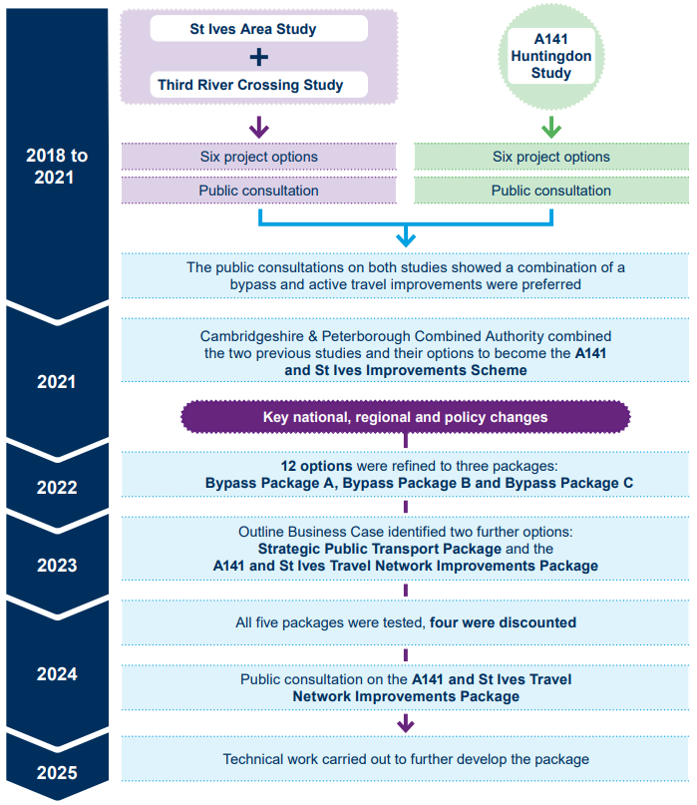
Source: A141 and St Ives Transport Improvements Scheme consultation October 2025

